Abstract Title (max. 40 words)

A. Smith^{1*}; B. Smith², etc..

¹Institution, City, Country, *Primary author contact details: emailaddress@email.com
²Institution, City, Country, etc..

- Introduction
This is the introduction section of your abstract. All section headings are in a size 10 Arial bold font. Sections can be with or without numbering. Paragraphs and headings should have trailing vertical whitespace of 6pt.
  - Sub-section
This is an example of a sub-section.
- This is a bullet point.
- This bullet point is equally important.

- Figures
To insert figures, you should use the “Figure_caption” auto formatting style for the caption. Please do not insert large image files (> 1MB) into the document.
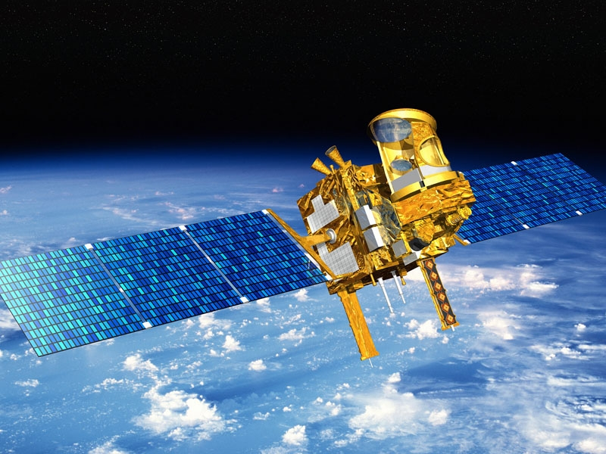
Figure 1: This is an example of a figure.
- Tables
Column 1 | Column 2 | Column 3
Line 1 | Line 1 | Line 1
Line 2 | Line 2 | Line 2
Line 3 | Line 3 | Line 3
Table 1: This is an example of a table
- Equations
To insert equations use either formatted text (for simple equations that do not require complex symbols), the built-in MS Word equation editor, or pictures of typeset equations. The equation number should be placed at the right side of the column and all equations should be consecutively numbered.
(1)
- File format and page dimensions
When you have finished your abstract please save it in the same format as this template, MS Word ‘.docx’. Unfortunately, PDFs are not able to be processed for compilation of the conference proceedings and consequently will not be accepted. The correct page settings for A4 size, 237 (height) x 180 (width) mm, are set for this document. Page size and page margins should not be altered.
Before you submit please carefully check your abstract is as you intend, and without mistakes. We are unable to accept updates after the abstract submission deadline.
- References
[1] Author, A., Author, B., and Author, C.: First example of a cited article title, First Example Journal, Vol. 1, pp. 1-100, 1999.
[2] Author, D. and Author, E.: Second example of a cited book, Example Publishing House, 2000.

